**Demo: Creating and Cloning a GitHub Repository**

**Objective:** To create and clone a GitHub repository for understanding the fundamentals of repository management and version control using Git and GitHub

**Tools required:** Git and GitHub

**Prerequisites:** We need to have Git installed and a GitHub account to proceed with this demo.

**Steps to be followed:**

1. Create a new GitHub repository
2. Clone the GitHub repository

**Step 1: Create a new GitHub repository**

* 1. Open the browser in your lab, go to **github.com**, and log in to your account



**Note**: If you do not have a GitHub account, visit the official website at https://github.com/signup and create a new account

* 1. Click on the + icon from the upper-right corner of the page and select **New repository** from the drop-down menu

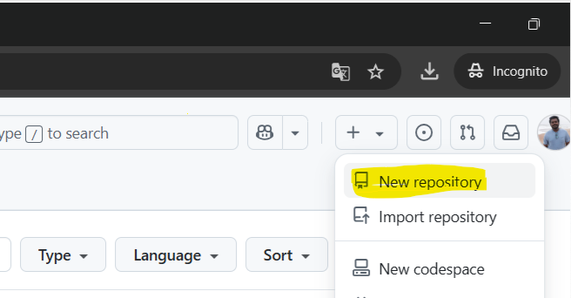

1.3 Enter the **Repository name** and **Description** as shown below:

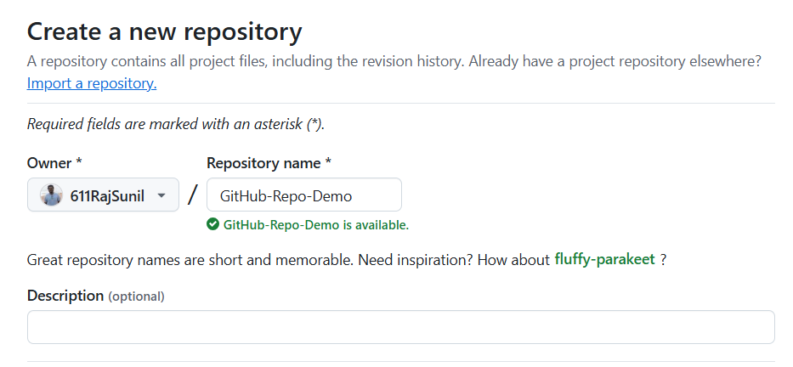

**Note:** The repository name and description may differ from those shown in the screenshot.

**1.4** Choose **Public** for the repository type

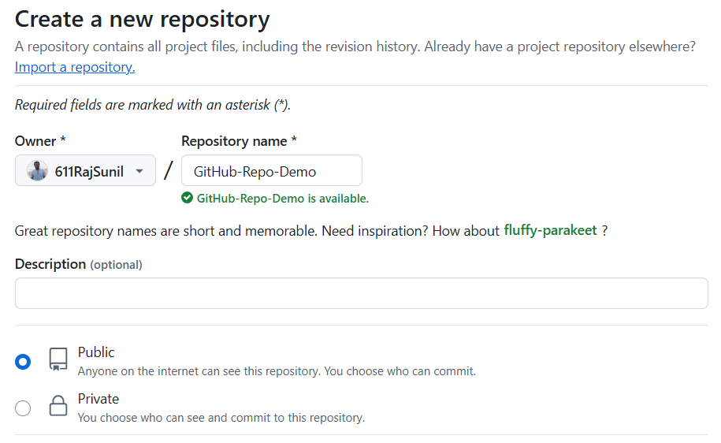

**1.5** Select Add a **README** file option to include a **README file** for the repository

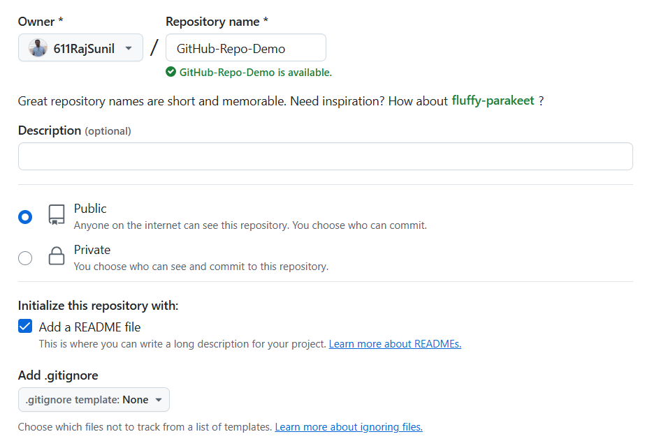

**1.6** Click on the **Create repository** button

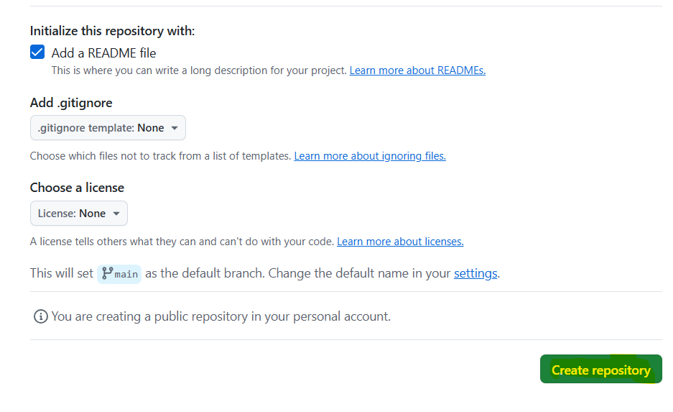

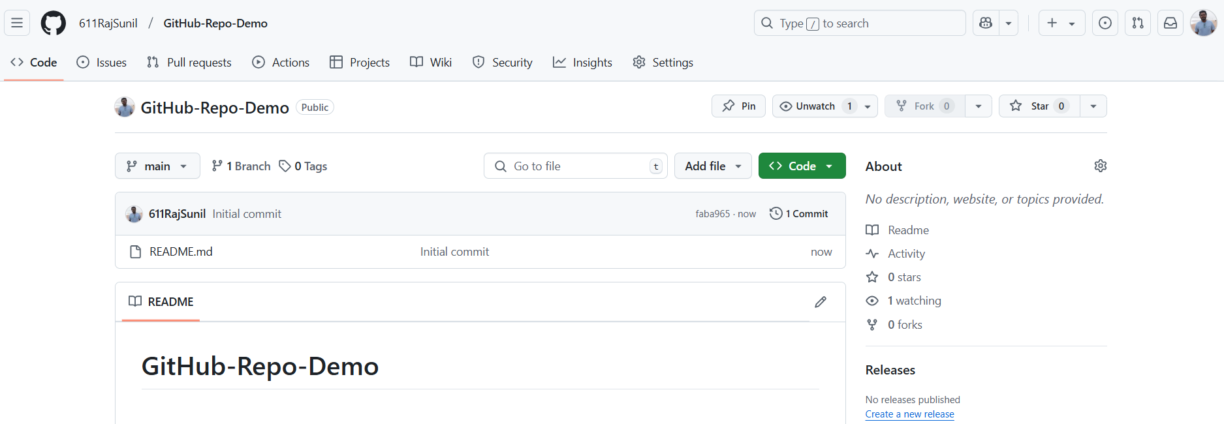

The remote **GitHub repository** is created

**Step 2: Clone the GitHub repository**

**2.1** Open the created repository and click on the **Code button**

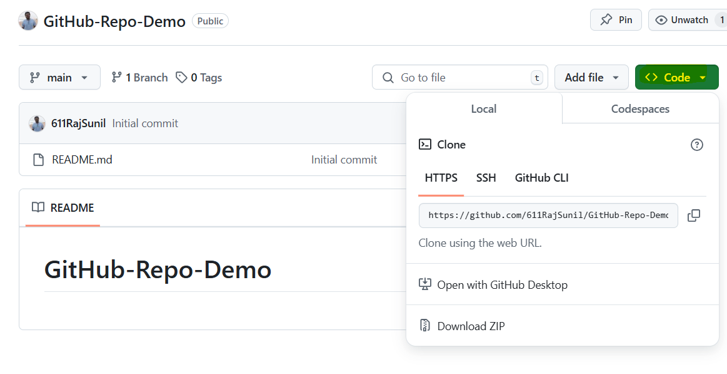

**2.2** Click on the copy icon to copy the **HTTPS URL** as shown below:

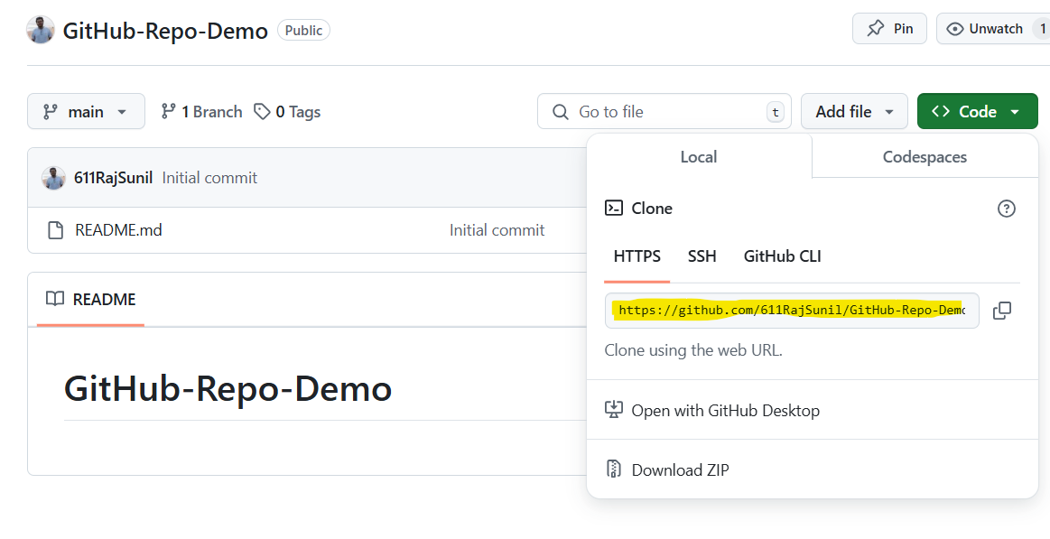

**2.3** Open the terminal tab on your lab and use the following command to clone the repository:

**git clone <URL>**

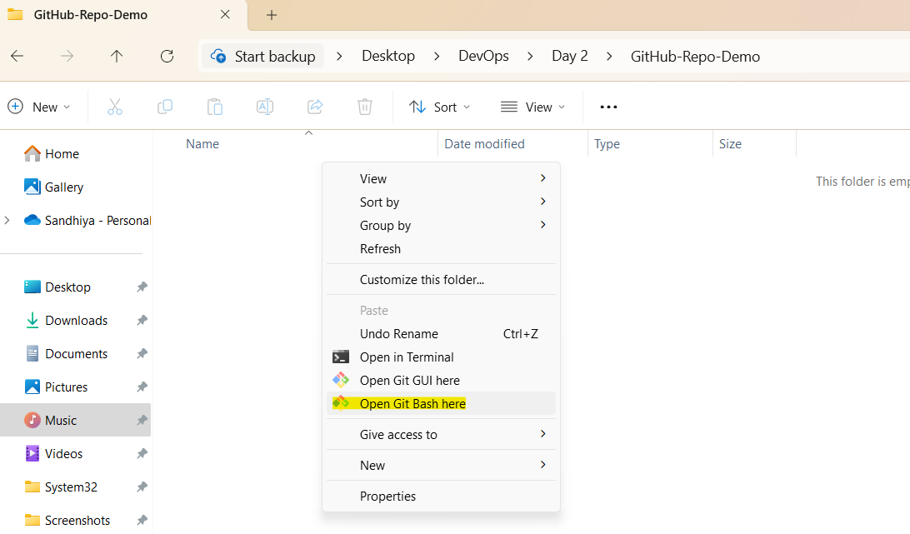

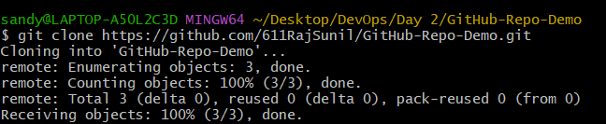

**Note:** Replace the URL in the command with the copied HTTPS URL from the GitHub repository

**By following these steps, you have successfully created and cloned a GitHub repository for understanding the fundamentals of repository management and version control using Git and GitHub.**